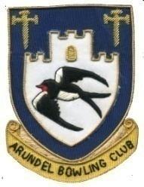
APPLICATION FOR MEMBERSHIP

Title: | First Name | Surname:

Address:  Post Code: | Home Telephone No.  Mobile Tel. No.  Car Registration:
Email address:

How many years have you been bowling?  Outdoor Indoor  Short Mat or New Bowler | Name of previous club – if any

Please tick the type of membership for which you are applying:
Full Membership, year-round, includes Short Mat and Social membership | £125
Short Mat Membership, October to April, includes Social membership | £60
Social membership only, year-round | £20

Members are required to participate in various tasks as a condition of membership. A rota is prepared at the beginning of the season and each member allotted tasks such as preparing refreshments and tea for home matches, cleaning the pavilion, etc.
Members may also purchase a club shirt @ £25. Please tick box if required

Members may access the clubhouse by requesting a set of keys, for which a refundable deposit of £25 is required. Please tick the box if required

Bank payment details: Arundel Bowling Club A/C 40654752 Sort Code 20-20-65

Signature of applicant: | Date:
Please return your completed form to:
Sheila Wells, 15 Fontwell Close, Fontwell, Arundel BN18 0SW or by email to arundelbowlingclub@outlook.com

